Java GUI (Applets vs Applications) : Chapter 8

Java Applet
Applet is a special type of program that is embedded in the webpage to generate the dynamic content. It runs inside the browser and works at client side.

Advantage of Applet
There are many advantages of applet. They are as follows:
- It works at client side so less response time.
- Secured
- It can be executed by browsers running under many plateforms, including Linux, Windows, Mac Os etc.

Drawback of Applet
- Plugin is required at client browser to execute applet.

Hierarchy of Applet
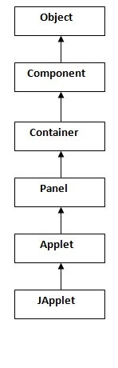
As displayed in the above diagram, Applet class extends Panel. Panel class extends Container which is the subclass of Component

Lifecycle of Java Applet
- Applet is initialized.
- Applet is started.
- Applet is painted.
- Applet is stopped.
- Applet is destroyed.

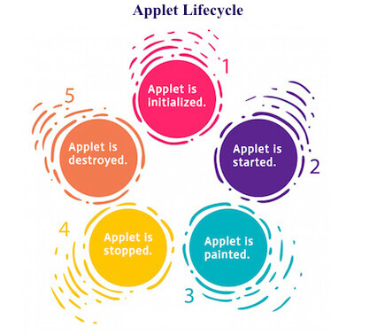

java.applet.Applet class
For creating any applet java.applet.Applet class must be inherited. It provides 4 life cycle methods of applet.
- public void init(): is used to initialized the Applet. It is invoked only once.
- public void start(): is invoked after the init() method or browser is maximized. It is used to start the Applet.
- public void stop(): is used to stop the Applet. It is invoked when Applet is stop or browser is minimized.
- public void destroy(): is used to destroy the Applet. It is invoked only once.

java.awt.Component class
The Component class provides 1 life cycle method of applet.
- public void paint(Graphics g): is used to paint the Applet. It provides Graphics class object that can be used for drawing oval, rectangle, arc etc.

Simple example of Applet by html file:
To execute the applet by html file, create an applet and compile it. After that create an html file and place the applet code in html file. Now click the html file.
- //First.java
- import java.applet.Applet;
- import java.awt.Graphics;
- public class First extends Applet{

- public void paint(Graphics g){
- g.drawString("welcome",150,150);
- }

- }

myapplet.html
- <html>
- <body>
- <applet code="First.class" width="300" height="300">
- </applet>
- </body>
- </html>

Simple example of Applet by appletviewer tool:
To execute the applet by appletviewer tool, create an applet that contains applet tag in comment and compile it. After that run it by: appletviewer First.java. Now Html file is not required but it is for testing purpose only.
- //First.java
- import java.applet.Applet;
- import java.awt.Graphics;
- public class First extends Applet{

- public void paint(Graphics g){
- g.drawString("welcome to applet",150,150);
- }

- }
- /*
- <applet code="First.class" width="300" height="300">
- </applet>
- */
To execute the applet by appletviewer tool, write in command prompt:
c:\>javac First.java
c:\>appletviewer First.java

Example of displaying image in applet:

- import java.awt.*;
- import java.applet.*;

- public class DisplayImage extends Applet {

- Image picture;

- public void init() {
- picture = getImage(getDocumentBase(),"sonoo.jpg");
- }

- public void paint(Graphics g) {
- g.drawImage(picture, 30,30, this);
- }

- }

EventHandling in Applet
As we perform event handling in AWT or Swing, we can perform it in applet also. Let's see the simple example of event handling in applet that prints a message by click on the button.

Example of EventHandling in applet:

- import java.applet.*;
- import java.awt.*;
- import java.awt.event.*;
- public class EventApplet extends Applet implements ActionListener{
- Button b;
- TextField tf;

- public void init(){
- tf=new TextField();
- tf.setBounds(30,40,150,20);

- b=new Button("Click");
- b.setBounds(80,150,60,50);

- add(b);add(tf);
- b.addActionListener(this);

- setLayout(null);
- }

- public void actionPerformed(ActionEvent e){
- tf.setText("Welcome");
- }
- }
In the above example, we have created all the controls in init() method because it is invoked only once.

Java AWT Tutorial
Java AWT (Abstract Window Toolkit) is an API to develop GUI or window-based applications in java.
Java AWT components are platform-dependent i.e. components are displayed according to the view of operating system. AWT is heavyweight i.e. its components are using the resources of OS.
The java.awt package provides classes for AWT api such as TextField, Label, TextArea, RadioButton, CheckBox, Choice, List etc.

Java AWT Hierarchy
The hierarchy of Java AWT classes are given below.

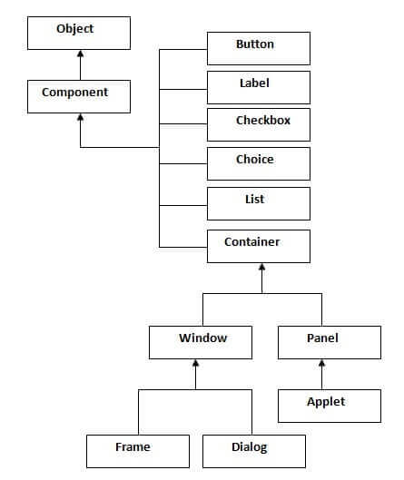

Container
The Container is a component in AWT that can contain another components like buttons, textfields, labels etc. The classes that extends Container class are known as container such as Frame, Dialog and Panel.

Window
The window is the container that have no borders and menu bars. You must use frame, dialog or another window for creating a window.

Panel
The Panel is the container that doesn't contain title bar and menu bars. It can have other components like button, textfield etc.

Frame
The Frame is the container that contain title bar and can have menu bars. It can have other components like button, textfield etc.

AWT Example by Inheritance
Let's see a simple example of AWT where we are inheriting Frame class. Here, we are showing Button component on the Frame.
- import java.awt.*;
- class First extends Frame{
- First(){
- Button b=new Button("click me");
- b.setBounds(30,100,80,30);// setting button position
- add(b);//adding button into frame
- setSize(300,300);//frame size 300 width and 300 height
- setLayout(null);//no layout manager
- setVisible(true);//now frame will be visible, by default not visible
- }
- public static void main(String args[]){
- First f=new First();
- }}
download this example
The setBounds(int xaxis, int yaxis, int width, int height) method is used in the above example that sets the position of the awt button.

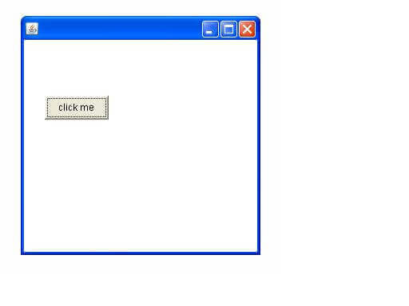

Java Event classes and Listener interfaces
Event Classes | Listener Interfaces
ActionEvent | ActionListener
MouseEvent | MouseListener and MouseMotionListener
MouseWheelEvent | MouseWheelListener
KeyEvent | KeyListener
ItemEvent | ItemListener
TextEvent | TextListener
AdjustmentEvent | AdjustmentListener
WindowEvent | WindowListener
ComponentEvent | ComponentListener
ContainerEvent | ContainerListener
FocusEvent | FocusListener

Java event handling by implementing ActionListener
- import java.awt.*;
- import java.awt.event.*;
- class AEvent extends Frame implements ActionListener{
- TextField tf;
- AEvent(){

- //create components
- tf=new TextField();
- tf.setBounds(60,50,170,20);
- Button b=new Button("click me");
- b.setBounds(100,120,80,30);

- //register listener
- b.addActionListener(this);//passing current instance

- //add components and set size, layout and visibility
- add(b);add(tf);
- setSize(300,300);
- setLayout(null);
- setVisible(true);
- }
- public void actionPerformed(ActionEvent e){
- tf.setText("Welcome");
- }
- public static void main(String args[]){
- new AEvent();
- }
- }
public void setBounds(int xaxis, int yaxis, int width, int height); have been used in the above example that sets the position of the component it may be button, textfield etc.

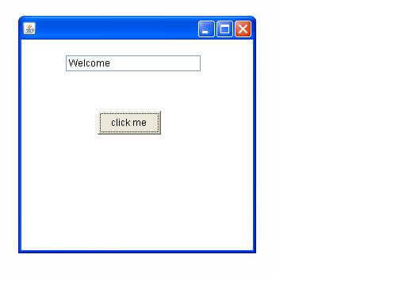

Difference between AWT and Swing
There are many differences between java awt and swing that are given below.
No. | Java AWT | Java Swing
1) | AWT components are platform-dependent. | Java swing components are platform-independent.
2) | AWT components are heavyweight. | Swing components are lightweight.
3) | AWT doesn't support pluggable look and feel. | Swing supports pluggable look and feel.
4) | AWT provides less components than Swing. | Swing provides more powerful components such as tables, lists, scrollpanes, colorchooser, tabbedpane etc.
5) | AWT doesn't follows MVC(Model View Controller) where model represents data, view represents presentation and controller acts as an interface between model and view. | Swing follows MVC.

What is Swing?
Java Swing is a lightweight Graphical User Interface (GUI) toolkit that includes a rich set of widgets. It includes package lets you make GUI components for your Java applications, and It is platform independent.
The Swing library is built on top of the Java Abstract Widget Toolkit (AWT), an older, platform dependent GUI toolkit. You can use the Java GUI components like button, textbox, etc. from the library and do not have to create the components from scratch.
Java Swing class Hierarchy Diagram
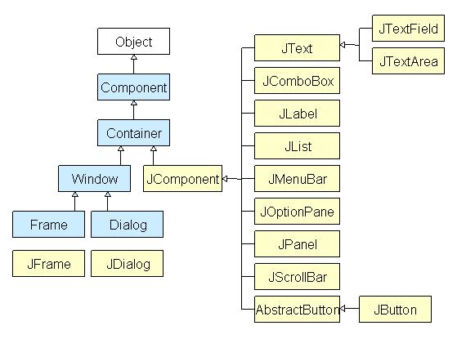

Simple Java Swing Example
Let's see a simple swing example where we are creating one button and adding it on the JFrame object inside the main() method.
File: FirstSwingExample.java
- import javax.swing.*;
- public class FirstSwingExample {
- public static void main(String[] args) {
- JFrame f=new JFrame();//creating instance of JFrame

- JButton b=new JButton("click");//creating instance of JButton
- b.setBounds(130,100,100, 40);//x axis, y axis, width, height

- f.add(b);//adding button in JFrame

- f.setSize(400,500);//400 width and 500 height
- f.setLayout(null);//using no layout managers
- f.setVisible(true);//making the frame visible
- }
- }
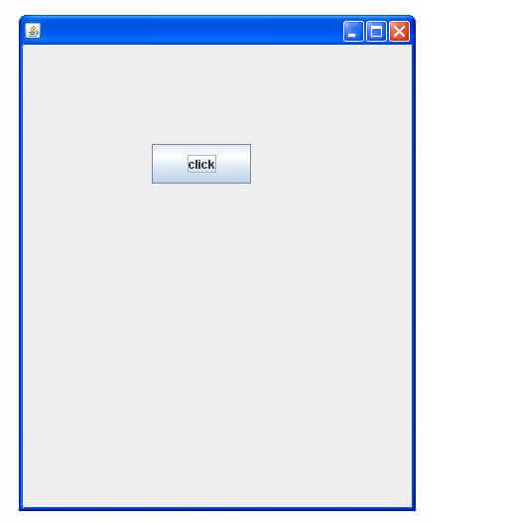

Example of Swing by Association inside constructor
We can also write all the codes of creating JFrame, JButton and method call inside the java constructor.
File: Simple.java
- import javax.swing.*;
- public class Simple {
- JFrame f;
- Simple(){
- f=new JFrame();//creating instance of JFrame

- JButton b=new JButton("click");//creating instance of JButton
- b.setBounds(130,100,100, 40);

- f.add(b);//adding button in JFrame

- f.setSize(400,500);//400 width and 500 height
- f.setLayout(null);//using no layout managers
- f.setVisible(true);//making the frame visible
- }

- public static void main(String[] args) {
- new Simple();
- }
- }
The setBounds(int xaxis, int yaxis, int width, int height)is used in the above example that sets the position of the button.

Simple example of Swing by inheritance
We can also inherit the JFrame class, so there is no need to create the instance of JFrame class explicitly.
File: Simple2.java
- import javax.swing.*;
- public class Simple2 extends JFrame{//inheriting JFrame
- JFrame f;
- Simple2(){
- JButton b=new JButton("click");//create button
- b.setBounds(130,100,100, 40);

- add(b);//adding button on frame
- setSize(400,500);
- setLayout(null);
- setVisible(true);
- }
- public static void main(String[] args) {
- new Simple2();
- }}

package com.applets;

import java.applet.Applet;
import java.awt.Button;
import java.awt.Color;
import java.awt.GridLayout;
import java.awt.Label;
import java.awt.TextArea;
import java.awt.TextField;
import java.awt.event.ActionEvent;
import java.awt.event.ActionListener;
import javax.swing.JOptionPane;

public class EnquiryForm extends Applet implements ActionListener
{
private static final long serialVersionUID = 1L;
Label l1,l2,l3,l4,l5,l6;
TextField t1,t2,t3;
TextArea t4;
Button b1,b2;

@Override
public void init()
{

setSize(300, 200);
setLayout(new GridLayout(6,2));
setBackground(Color.pink);

l1 = new Label("Full Name");
l2 = new Label("Phone");
l3 = new Label("Email");
l4 = new Label("Message");
l5 = new Label("");
l6 = new Label("");

t1 = new TextField(35);
t2 = new TextField(11);
t3 = new TextField(35);
t4 = new TextArea();

b1 = new Button("Submit");
b2 = new Button("Clear");

add(l1); add(t1); add(l2);add(t2);add(l3);add(t3);add(l4);
add(t4);add(l5);add(l6);add(b1);add(b2);

b2.addActionListener(this);
b1.addActionListener(this);

}

@Override
public void actionPerformed(ActionEvent ae)
{
if(ae.getSource()== b2)
{
t1.setText("");
t2.setText("");
t3.setText("");
t4.setText("");

}
if(ae.getSource()== b1)
{
if(t1.getText().equals("") || t2.getText().equals("") || t3.getText().equals("") || t4.getText().equals(""))
{
showStatus("All Fields data is Mandatory!!");
}
else
{
DMLOperations dbp = new DMLOperations();
String temp=null;
try
{
dbp.createConnection();
dbp.saveData(t1.getText(),t2.getText(),t3.getText(),t4.getText());
//dbp.createConnection();
//temp=dbp.getEnqId(t3.getText());
// System.out.println(temp);
JOptionPane.showMessageDialog(this, "Your Enquiry Reached us !!");
}
catch (Exception e)
{
JOptionPane.showMessageDialog(this, "There is some network issue");
}

}
}

}

}

DML Operations:
package com.applets;

import java.sql.*;
import java.util.HashSet;
import java.util.Set;
//import java.io.*;
class DMLOperations
{
public Connection con;
public int rowsEffected;
public PreparedStatement pstmt;
public ResultSet rs;

public int createConnection()throws Exception
{
con=null;
Class.forName("com.mysql.jdbc.Driver");

System.out.println("Driver Loaded.....");

String databaseURL = "jdbc:mysql://localhost:3306/javaclass";
try {
con = DriverManager.getConnection(databaseURL,"root","abcd@143");

}
catch(SQLException e)
{
System.out.println("hello."+e);
}

System.out.println("Database Connected ");

return 0;
}
public ResultSet searchDet(int s)throws Exception
{
pstmt=null;
pstmt=con.prepareStatement("select * from emp where eno=?");
pstmt.setInt(1, s);

rs=pstmt.executeQuery();
rs.first();
//String t=rs.getString(2);
//System.out.println(t);
return rs;
}
public void saveData(String s1,String s2,String s3,String s4)throws Exception
{
pstmt=null;
//LAST_INSERT_ID
pstmt=con.prepareStatement("insert into feedback values(?,?,?,?)");

pstmt.setString(1, s1);
pstmt.setString(2, s2);
pstmt.setString(3, s3);
pstmt.setString(4, s4);

rowsEffected=pstmt.executeUpdate();
System.out.println(rowsEffected + " Rows Updated ");
pstmt.close();
con.close();

}
}

/*
* To change this license header, choose License Headers in Project Properties.
* To change this template file, choose Tools | Templates
* and open the template in the editor.
*/
package com.jdbc1;

import java.sql.*;
import java.util.logging.Level;
import java.util.logging.Logger;
/**
*
* @author A B Pradeep
*/
class Database
{
public Connection con;
public int rowsEffected;
public Statement stmt;
public ResultSet rs;
}
public class ShowData
{

public static void main(String arg[]) throws Exception
{
Database d = new Database();
d.con=null;

Class.forName("com.mysql.jdbc.Driver");

System.out.println("Driver Loaded.....");

String databaseURL = "jdbc:mysql://localhost:3306/javaclass";

d.con = DriverManager.getConnection(databaseURL,"root","abcd@143");

System.out.println("Database Connected ");

d.stmt=null;

d.stmt=d.con.createStatement(); //statement object created

d.rs=null;

d.rs=d.stmt.executeQuery("select * from student"); //can execute only Select statments

while(d.rs.next()) //as long as records available
{
System.out.println(d.rs.getString(1) + "\t" + d.rs.getString(2)+ "\t" + d.rs.getString(3)); //get values at ordinal positions of cols
}

d.rs.close(); //step 4
d.stmt.close();
d.con.close();
}
}

